**RESULTS AND DISCUSSION**

The multi user model includes data from multiple users . Thus, the prepared dataset include data from multiple user folders of the original geolife project dataset . The project code is developed in the python .py file . Therefore the code is executed in the command prompt . The functions use Tensorflow modules to create deep neural network model for the multi user purpose .

During execution the main function invokes all the function calls in it . The upload function access the dataset file present in the specified location . Then it opens up the data present in dataset file under read access . The dataset is loaded into a variable and a list is prepared for further use .

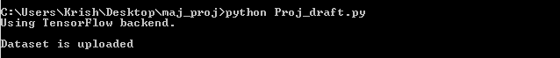

**Fig 8.1** Running code file and dataset upload

Now the function lstm model is invoked in order to generate a LSTM(Long Short Term Memory) model . This model is a deep neural network model that is designed to guide the process to the users next location . Thus the model consists of some input, output and dense layers .

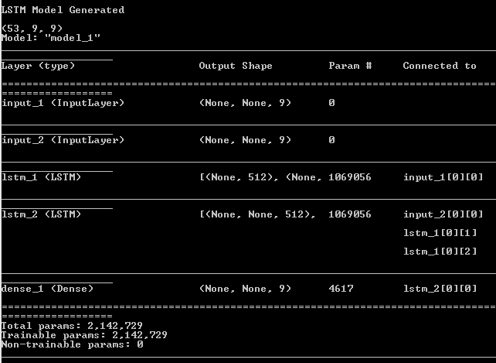

**Fig 8.2** LSTM model generation and the model attributes

The model generation is complete thus we train the model with the dataset that we have prepared which fits suitable for the project. The model is made up with encoders and decoders the idea behind the LSTM algorithm. The dataset in a csv file is passed on to the model and the list prepared in the beginning which consists of the values of dataset in a list format. All these resources are used in a processed way to train the model. And a certain number epochs are run while training the model. The metrics for the epoch are also displayed accordingly. And certain metrics like accuracy and MSE values are calculated.

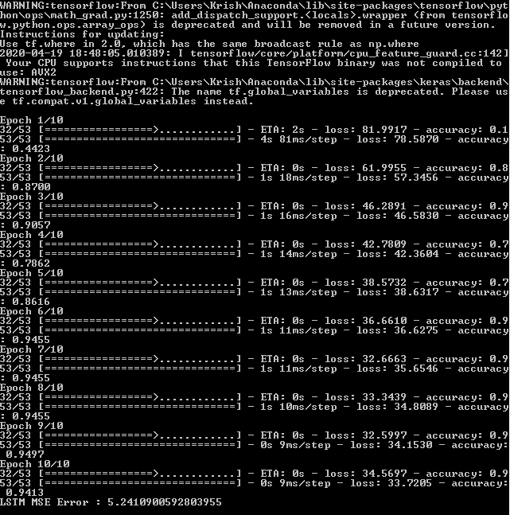

**Fig 8.3** Train the LSTM model with the epochs for better results

The next function is to predict the next location user using LSTM model created. The function requests for certain values of the user like longitude, latitude and user id. By providing those values to the model we predict the next location of the user. The model passes the data through the network created and predicts the next values.

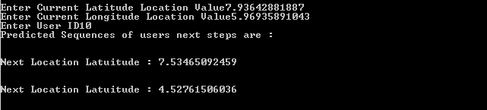

**Fig 8.4** Predicting user next location

The function we have invoked works on creating a model for EML regression algorithm. And this model helps us in predicting the next location of a particular user after all the user location points are trained. The model prepares a new location values which point to values that are potentially the next location after users last location. The function takes user id as input and training data is shown to know the latitude and longitude values. And displays finally calculated new location values.

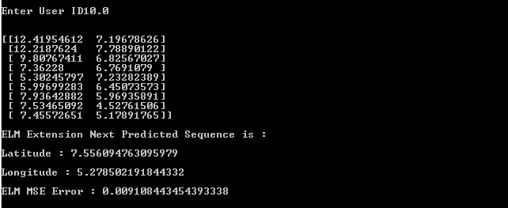

**Fig 8.5** EML regression model and new location prediction.